

|  |  |
| --- | --- |
| **Hands-on Exercise No. 1**  **DigiSkills**  **2.0 Batch-05 Freelancing** | **Total Marks: 10**  **Due Date: 27/07/2023** |

**STUDENT NAME**

**Uzma Ejaz**

**Tasks:**

* 1. Mention the skillset in which you want to pursue your freelancing career.
  2. Explore your skill (mentioned in Task-01) set in the search bar of Fiverr, such as logo design, article writing, Ad campaign, product listening, data entry, etc. (Take a screenshot of the search result). 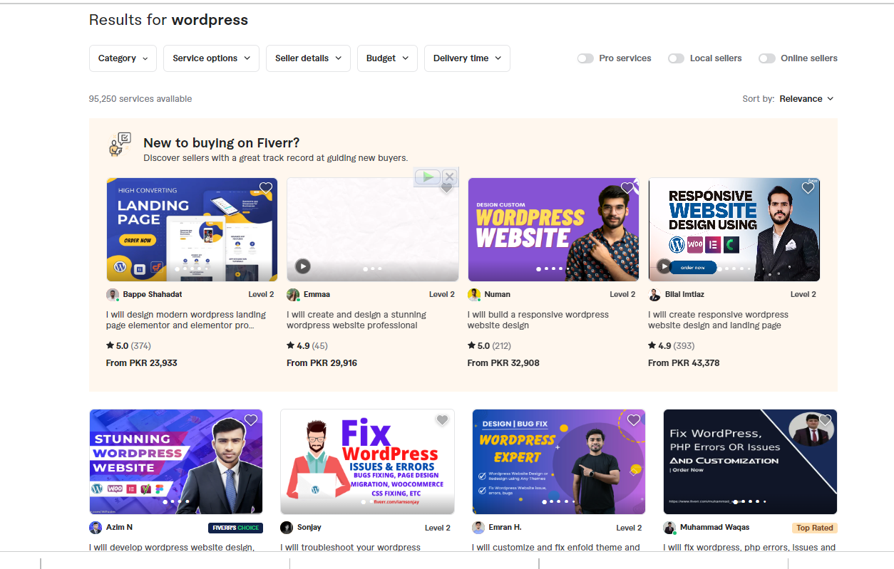

-----------------------------------------------------------------------

3.Write down the top 5 most relevant gig titles (NOT keywords) that you discovered during your search.

# I will create responsive WordPress website design and landing page.

# I will customize and fix enfold theme and fix WordPress website.

# I will fix Wordpress issues, errors, problems within 1 hour.

# I will create wordpress website design and development

# I will design responsive SEO blog wordpress web site on bluehost godaddy as expert

# --------------------------------------------------------------------------------------------------------------------